Password Strength Analyzer with Custom Wordlist Generator.

Introduction
This project helps in analyzing the strength of passwords using Python. It also generates custom wordlists based on user inputs like name, date of birth, and pet name. The tool enhances cybersecurity awareness and helps users create stronger passwords.

Objective
- Analyze password strength using the zxcvbn library.
- Provide suggestions to improve password security.
- Generate custom wordlists for security testing and penetration testing.

Tools & Technologies Used
- Python 3
- zxcvbn library for password strength analysis
- Standard Python libraries: datetime, collections
- Platform: Kali Linux or Windows
- python

Source Code
import tkinter as tk
from tkinter import messagebox, filedialog
from zxcvbn import zxcvbn
import datetime
from collections import OrderedDict

def analyze_password():
password = password_entry.get()
if not password:
messagebox.showerror("Error", "Please enter a password.")
return

result = zxcvbn(password)
score = result['score']
feedback = result['feedback']
warning = feedback.get('warning', '')
suggestions = feedback.get('suggestions', [])

result_text = f"Score: {score}/4\n"
if warning:
result_text += f"Warning: {warning}\n"
if suggestions:
result_text += "Suggestions:\n" + "\n".join(f" - {s}" for s in suggestions)

result_label.config(text=result_text)

def generate_wordlist():
name = name_entry.get().lower()
dob = dob_entry.get()
pet = pet_entry.get().lower()

try:
dob_parts = dob.split("-")
year, month, day = dob_parts
except:
messagebox.showerror("Error", "DOB format should be YYYY-MM-DD")
return

patterns = [
name, pet, year, month + day,
name + year, pet + year,
name + "123", name + "@123",
name + "!", name.capitalize(),
name + "2024", name + "2025",
name.replace('a', '@'),
name.replace('s', '$'),
name[::-1],
name + "!" + year,
pet.capitalize() + "@" + day,
name + pet,
name + pet + year
]

unique_words = list(OrderedDict.fromkeys(patterns))

file_path = filedialog.asksaveasfilename(defaultextension=".txt", title="Save Wordlist")
if file_path:
with open(file_path, 'w') as f:
for word in unique_words:
f.write(word + "\n")
messagebox.showinfo("Saved", f"Wordlist saved to {file_path}")

# -------- GUI SETUP --------
root = tk.Tk()
root.title("Password Strength Analyzer + Wordlist Generator")
root.geometry("500x500")

tk.Label(root, text="Enter Password:").pack()
password_entry = tk.Entry(root, show="*", width=40)
password_entry.pack()

tk.Button(root, text="Analyze Password", command=analyze_password).pack(pady=5)
result_label = tk.Label(root, text="", fg="blue", justify="left")
result_label.pack()

tk.Label(root, text="\n--- Wordlist Generator ---").pack()
tk.Label(root, text="Name:").pack()
name_entry = tk.Entry(root, width=40)
name_entry.pack()

tk.Label(root, text="DOB (YYYY-MM-DD):").pack()
dob_entry = tk.Entry(root, width=40)
dob_entry.pack()

tk.Label(root, text="Pet/Fav Word:").pack()
pet_entry = tk.Entry(root, width=40)
pet_entry.pack()

tk.Button(root, text="Generate Wordlist", command=generate_wordlist).pack(pady=10)

root.mainloop()
Sample output
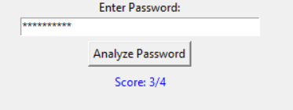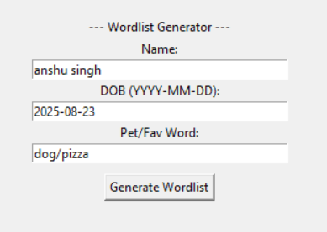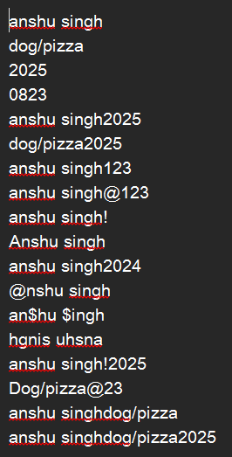

Conclusion
This project enhances understanding of password security by providing a tool to evaluate password strength and generate custom wordlists. It aids cybersecurity learning and can be extended for more advanced features.

Future Scope
- Integrate real-time breach checks using external APIs.
- Develop a GUI for improved user interaction.
- Store and analyze password strength history for users.

References
- https://owasp.org
- https://haveibeenpwned.com
- Python official documentation

